Creating a useful mark book and using Excel

- Open a new Excel document
- Open ‘SIMS Data Downloaded’ (this is a copy of a year 8 French data sheet).
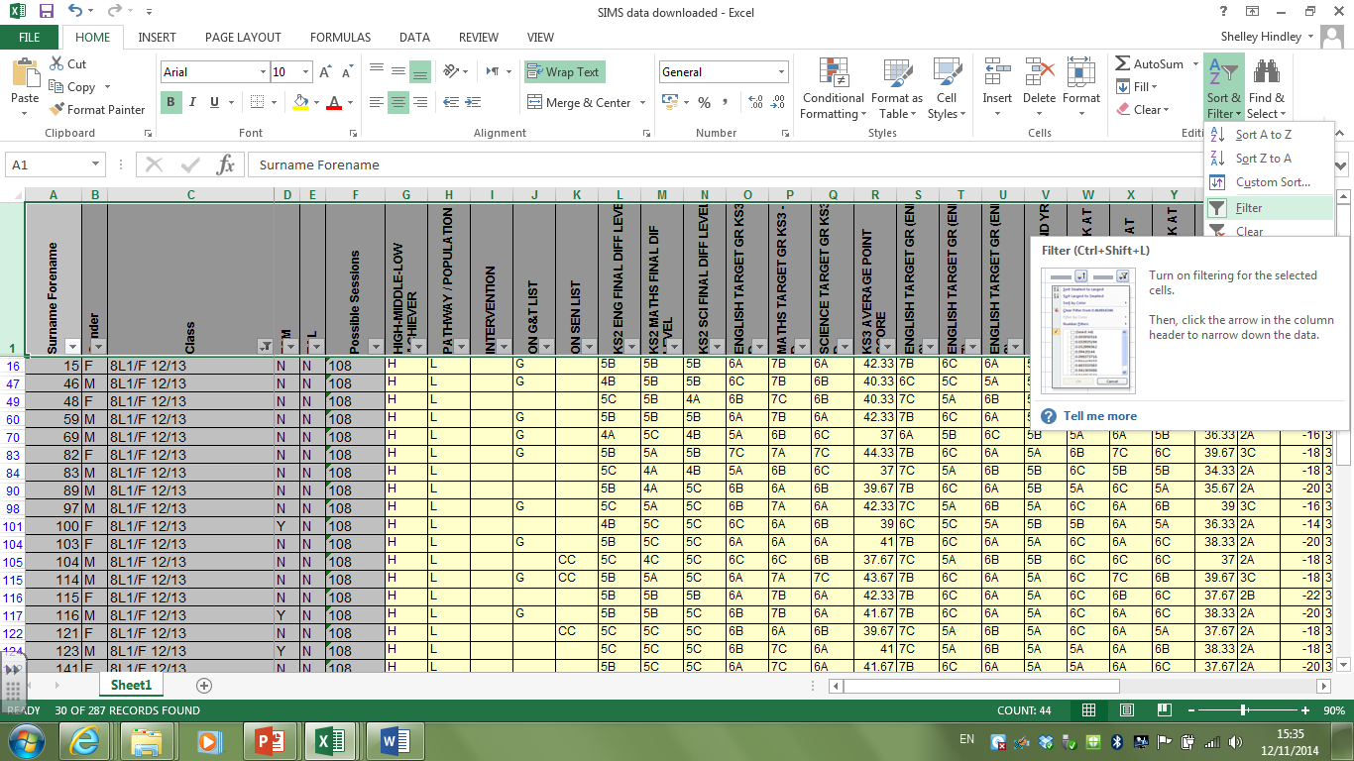
- We only want to see the data for class 8L1 so add a ‘filter’ (select Row 1 and click Sort and Filter from the ‘File’ tab), click on the drop down arrow on the ‘Class’ column and make sure that 8L1 is the only one ticked.
- Select and copy columns A, B, C, D, E and paste into your new spreadsheet. Select and copy the columns with the information on G&T, SEN, French target grade end of yr 8, and columns AL – AQ.
- Create your own column at the end called ‘Homework’ and give each student a ‘Y’ or and ‘N’ (yes they have done it, no they haven’t).
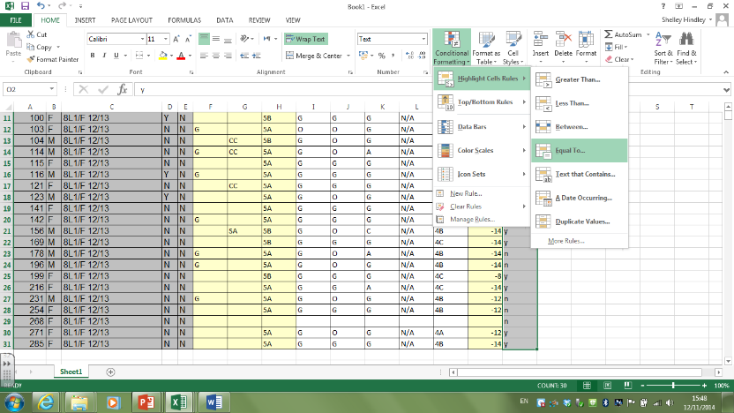
- Select the cells in your homework column (O2 – O31) and click on ‘Conditional Formatting’, ‘Highlight Cell Rules’, ‘Equal To’. Type Y, and choose ‘green fill …’.
- Repeat step 6, but type N and choose ‘Red fill …’. This easily allows you to see who has/hasn’t done homework.
- Right click on one of the cells in red, select Insert Comment – write that they lost the HW.
- Add a filter as in step 3. Find out which pupils are Working At level 4c. Who are they? ______________________________________________________________
- Reset the filter and sort the Working At column from A-Z (this shows your class in order of best – worst performers)
- Using 2 filters, find out how many girls are working at 4b _________
- Filter the AUT Comparison column to find out who is -14 or more away from their target grade _____________________________________________________________________________

More in Excel – GCSE tracker
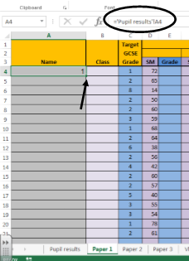
1) Mirroring data from one cell to another:
To avoid retyping names and other data.
- On the Paper 1 tab, in cell A4, type =’pupil results’!A4 , then enter. You should have the same pupil name in the cell as on the Pupil Results tab.
- Drag down the square on the bottom right of the cell to repeat the formula in the other cells.
Practise: try to do the same with the Class and Target Grade columns.

2) Creating Value Look Up tables:
To easily find out how a scaled mark translates to a grade.
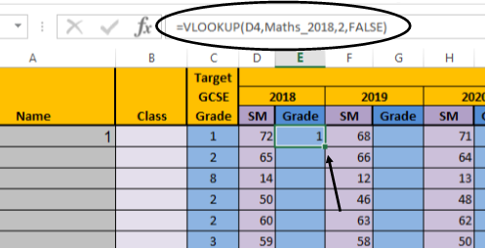
- On the Vlookup tables tab, select all of the table Maths 2018, right click, Define Name. Keep the suggested name Maths_2018.
- On the Paper 1 tab, select cell E4 and type =vlookup(D4,Maths_2018,2,false) , then enter. You should have the GCSE grade that the Scaled Mark translates to.
- Drag down the square on the bottom right of the cell to repeat the formula in the other cells.
Practise: try to do the same with the results from the 2019 and 2020 papers.
3) Finding the maximum/minimum/average score in a range:
To try to predict what score your pupils will attain in each GCSE test, based on past results.
- On the Pupil Results tab, select cell D4 and type =Max( , then click on the Paper 1 tab, you should still see the start of your formula in the formula box.
- Click on the SM cells for person 1 (D4, F4 and H4), adding a comma between each one and a closed bracket at the end, then enter. Your formula should complete itself in the formula box. You should see the highest of the three scores in the Paper 1 scaled mark cell on the Pupil Results tab.
- Drag down the square on the bottom right of the cell to repeat the formula in the other cells.
Practise: try to do the same with the results from Paper 2 and Paper 3.
**To find the minimum or average score in a range, replace =Max( with =Min( or =Average(.**

4) Calculating the total Scaled Mark:
To find out what the final grade would be.
- On the Pupil Results tab, select cell G4 and type =sum(D4:F4) , then enter. This adds up the values in the cells from D4, up to and including F4, you could also do this by typing the individual cell names e.g. =sum(D5+E5+F5) .
- Drag down the square on the bottom right of the cell to repeat the formula in the other cells.
5) Calculating the overall total grade:
To find out the overall grade based on the 3 papers.
- Use the Vlookup formula in step 2) in cell H4 on the Pupil Results tab, and the Overall Grade Boundaries table on the Vlookup Tables tab.
- Drag down the square on the bottom right of the cell to repeat the formula in the other cells.
6) Calculating points away or over grade boundaries:
To find out who is comfortably, or only just reaching a grade.
- On the Pupils Results tab, select cell I4 and type =sum(1-G4) , then enter. The 1 is the minimum score required for a grade 9. This will show you how many points a pupil needs to reach a grade boundary (if the formula returns a negative number, this means that the pupil has passed the minimum grade boundary score by the number of points shown).
- Select cell J4 and type =sum(27-G4) , then enter. 27 is the minimum score required for a grade 8.
- Do the same for the other grades in row 4, remembering to change the minimum grade boundary score each time, these can be found in row 3.
- Drag down the square on the bottom right of the cells to repeat the formula in the cells below.
7) Using Conditional Formatting to colour code met grade boundaries:
To quickly and easily see which grades have been reached.
- On the Pupil Results tab, select the block of cells I4 to Q201, scroll up whilst keeping the cells selected.
- On the Home tab, select Conditional Formatting, Colour Scales, More Rules. In the Minimum Type drop down tab, change Lowest Value to Number and type 0 in the value box below and change the colour to green.
- In the Maximum type drop down tab, change Highest Value to Number and type 1 in the value box and change the colour to red. Click Ok.
- This should show in green, who has achieved enough points for each grade, and should show in red the grades that have not yet been achieved.
8) Using conditional formatting to highlight grades:
To quickly see who is meeting their targets by giving each GCSE grade a colour on a scale.
- Type in the Overall Total Grade that each pupil is meeting in the first Predicted Grades column, there are several columns to allow you to track how the predicted grades change over the GCSE years, rather than the data changing every time you complete a mock assessment.
- Select cells C4 to C201, with the cells selected, press and hold the Ctrl key, this allows you to select more cells that are not adjacent to the cells currently selected.
- Whilst holding the Ctrl key, select cells H4 to H201, and then R4 to Y201. Release Ctrl.
- With these cells selected, on the Home tab, select Conditional Formatting, Highlight Cell Rules, Equal To, type 1 and in the drop down box select Custom Format, then the Fill tab. Choose a bright green colour, you may need to click on More Colours to find one. Click Ok.
- With the cells still selected, select Conditional Formatting again, as above, but type 2 and choose a lighter green. Do the same for the other numbers 3 – 9, choosing a colour that goes down your chosen colour scale e.g. greens to yellows to oranges to blues. You should see that the cells on your spreadsheet are changing colour.
9) Freezing rows and columns to easily scroll across and compare data:
To move up and down the spreadsheet without losing row and column headings.
- On Pupil Results tab, select cell D4, on the View tab, select Freeze Panes and Freeze Panes.
- Now when you scroll down or across, anything above or to the left of cell D4 will not move.
- To unfreeze the panes, should you need to, select Freeze Panes and Unfreeze Panes.
10) Counting how many pupils have attained certain grades against targets:
To calculate your targets as a teacher using the mock grades and the target grades.
- On Pupil Results tab, select cell AB4 and type =countif($H$4:$H$201,AA4) , then enter. The $ signs tell Excel to keep looking in the same cell even when you drag down the formula to the other cells.
- Drag down the square on the bottom right of the cells to repeat the formula in the cells below.
- Select cell AC4 and type =countif($C$4:$C$201,AA4) , then enter. This counts how many of each target grade you should have.
- Drag down the square on the bottom right of the cells to repeat the formula in the cells below.
- Calculate the totals of cells AB4 to AB12 in cell AB13 using =sum(AB4:AB12) , then enter. Do the same for the Target no. of pupils column. The totals should be the same.
- Calculate the % of pupils. In cell AD4 type =sum((AB4/$AB$13)*100) , then enter.
- Drag down the square on the bottom right of the cells to repeat the formula in the cells below.
- Select cell AE4 and type =sum((AC4/$AB$13)*100) , then enter.
- Calculate the totals, they should both add up to 100.

